18 March, 2016

Ladies and Gentlemen of the Navy Nuclear Weapons Association,

The document presented below is a transcript of a letter I received from CDR William H. (Harry) Austin, USN (Ret). On the East Coast he was affectionately known as “Mr. Nuclear Weapons”. In response to a request from me he provided his personal history and experiences in the Navy and in the Nuclear Weapons program. I received this letter in August or September, 1999 along with the large package of material that is now a part of the NNWA memorabilia collection. The letter was written on a thin absorbent paper which was water damaged upon receipt. The letter has been in my possession since.

I brought the letter to the Tennessee reunion intending to provide it to our new Historian, Guy Clemons, with the hope that he might be able to do something with it or at least include it in the memorabilia. During that reunion it was misplaced. Until recently I thought it was gone forever, but while sorting through what I thought were empty folders I rediscovered Harry’s letter. I have spent several difficult but rewarding days deciphering the words included below.

The next page is a copy of page one of the five pages I worked with. As you can see, the subject page is heavily smeared and an imprint of the following page has bled through from the back. I used several types of magnifying lenses singly and in combination, back lighting, and expanded copies to make sense of the entire document. I am very pleased with the outcome and happy to be able to present this important view of Navy nuclear weapons history to you.

The original letter and my transcript will be provided to the NNWA Historian for inclusion in the Harry Austin portion of the memorabilia.

My transcript follows, nearly line for line, his original organization. I made no guesses or modifications to his spelling, grammar, and punctuation. I think I was able to read all his words and retype them just as he wrote them. In six places I added a word or two to clarify what Harry said. These are in parenthesis and highlighted in yellow (Yellow).

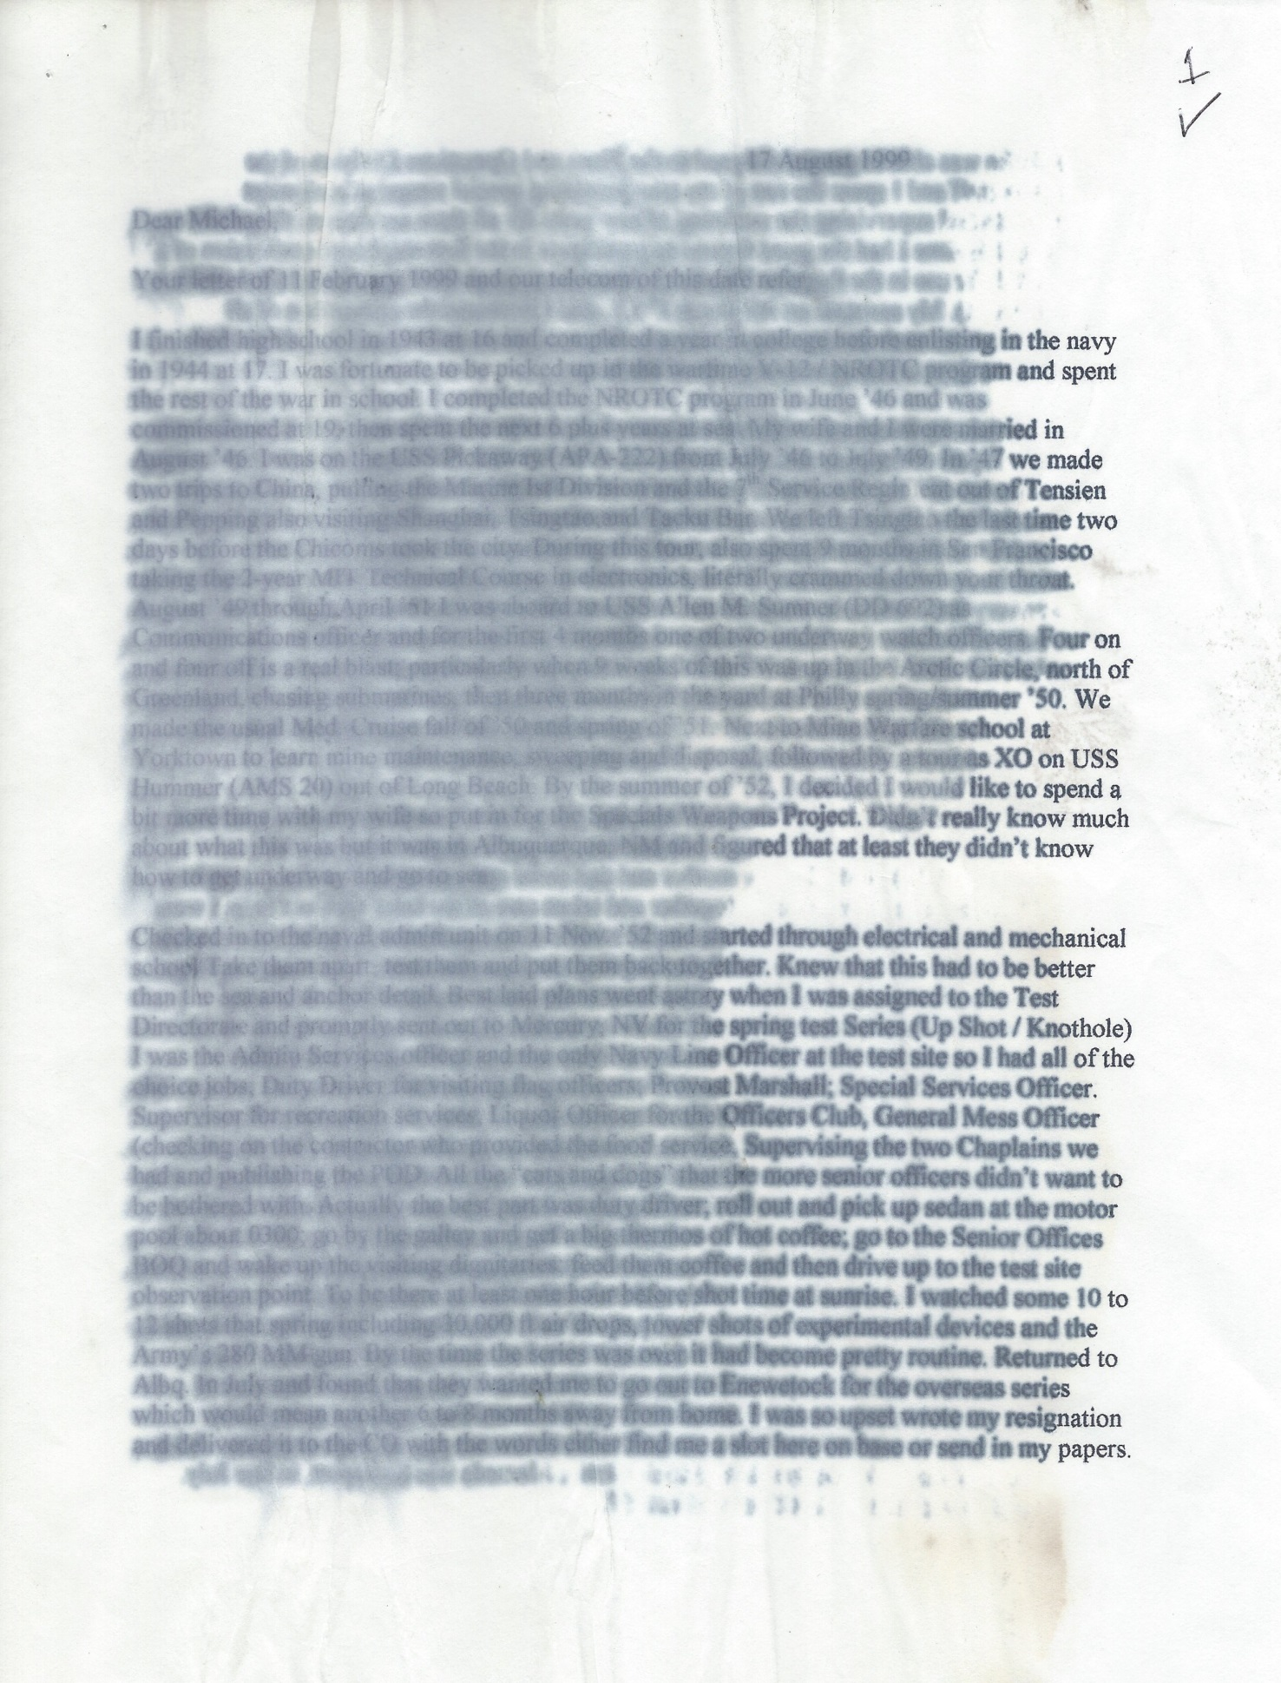

In his letter Harry notes that while aboard USS Ticonderoga (CVA 14) the deployed Special Weapons Unit was told they were to be converted to ships’ company. That conversion occurred in late 1957 or early 1958 before the ship returned home from deployment. All the other deployable SWU’s were similarly treated or were disbanded with the men distributed to other nuclear capable commands That explains why, as a GMTSN reporting to the USS Kitty Hawk (CVA-63) pre-commissioning detail in Norfolk in 1960, I found myself working for and with ET’s, GM’s, AO’s, EM’s, MR’s, BM’s and many more and varied rates.

I hope you enjoy reading about Harry Austin and his remarkable career. Like many line officers, he moved in and out of special weapons billets as the Bureau of Naval Personnel dictated. He retired from the Navy in September, 1969 with 25 years of service. In 1970 Harry was contacted by the CINCLANT personnel department and he ressumed his role in the Nuclear Weapons Program as a civilian. He retired again from CINCLANT in 1992. Harry and his wife attended the NNWA reunion in Oklahoma City in ’95 and the Portsmouth, VA reunion in 1998. We lost Harry Austin in 2010.

Michael D. Snyder,

LCDR, USN, (Ret)

NNWA Past President, Past Historian

17 August, 1999

Dear Michael,

Your letter of 11 February, 1999 and our telcon of this date refer.

I finished high school in 1943 at 16 and completed a year of college before enlisting in the Navy in 1944 at 17. I was fortunate to be picked up in the wartime V-12/NROTC program and spent the rest of the war in school. I completed the NROTC program in June ’46 and was commissioned at 19 and spent the next six years at sea. My wife and I were married in August ’46. I was on the USS Pickaway (APA-222) from July ’46 to July ’49. In 1947 we made two trips to China pulling the Marine 1st Division and the 7th Service Regiment out of Tensien and Pepping also visiting Shanghai, Tsingtao, and Tacku Bar. We left Tsingtao the last time two days before Chicoms took the city. During this tour also spent nine months in San Francisco taking the two year MIT course in electronics, literally crammed down your throat. August ’49 through April ’51 I was aboard USS Allen M. Sumner (DD-602) as Communications Officer and for the first four months one of two underway watch officers, Four on and four off is a real blast particularly when 9 weeks of this was up in the Arctic Circle, north of Greenland, chasing submarines, then three months in the yard at Philly spring/summer’50. We made the usual Med Cruise fall of ’50 and spring of ’51. Next to Mine Warfare School at Yorktown to learn mine maintenance, sweeping and disposal followed by a tour as XO on USS Hummer (AMS-20) out of Long Beach. By the summer of ’52 I decided I would like to spend a bit more time with my wife so put in for the Special Weapons Project. Didn’t really know much about what this was but it was in Albuquerque, NM and figured that at least they didn’t know how to get underway and go to sea.

Checked into the Naval Administration (Unit) on 11 Nov ’52 and started through electrical and mechanical school. Take them apart, test them and put them back together. Knew that this had to be better than the sea and anchor detail. Best laid plans went awry when I was assigned to Test Directorate and promptly sent out to Mercury, NV for the spring test series (Up Shot/Knothole). I was the admin/service officer and the only Navy Line Officer at the test site so I had all of the choice jobs; duty driver for visiting flag officers, Provost Marshall, Special Services Officer, Supervisor for recreation services, Liquor Officer for the Officers Club, General Mess Officer (checking on the contractor who provided the food service), Supervising the two Chaplains we had, and publishing the POD. All the “cats and dogs” that the more senior officers didn’t want to be bothered with. Actually, the best part was duty driver, roll out, pick up the sedan at the motor pool about 0600, go to the galley and get a big thermos of hot coffee; go to the Senior Officers BOQ and wake up the visiting dignitaries, feed them coffee and then drive them up to the test site observation point to be there one hour before shot time at sunrise. I watched some 10 to 12 shots that spring including 10,000 foot air drops, tower shots of experimental devices and the Army’s 280 MM gun. By the time the series was over it had become pretty routine. Returned to Albq. and found that they wanted me to go out to Eniwetok for the overseas series which would mean another 6 to 8 months away from home. I was so upset I wrote my resignation and delivered it to the CO with the words either he find me a slot here on base or send in my papers.

Fortunately he was able to get me assigned to the Plans and Operations Division of the Headquarters staff and I spent the rest of my tour providing special weapons equipment allowance lists and supervising the outfitting of new units for all three services as they came on line. During this time I had the good fortune to participate in the first shipboard conversion of a Mk5 to a W5 for use in the Regulus missile on board a carrier at the Puget Sound yard (think it was Hancock). My assistant, an Air Force 1st Lt., and I instituted the conversion of all equipment lists into each services supply system. We worked ourselves out of a job so then shifted into the day to day operation side of the house.

While I was in Long Beach my wife had contracted chicken pox and she was told it would settle in the weakest part of the body and this turned out to be her ears. She started to lose some hearing so in the summer of ’54 I was able to get transferred to Washington, DC where I could put her into Bethesda Naval Hospital. She went through months of testing at Bethesda and Walter Reed before the doctors finally decided there was only hope in major ear surgery. She had a fenestration in the left ear (summer’ 55) and was able to regain about 60% of her hearing on that side. I was very fortunate to be assigned as the Weapons Officer on the personal staff of the Ass’t to the Secretary of Defense for Atomic Energy. A fantastic job for a then Lieutenant. Our offices were in the main AEC Building at 20th and Constitution in the District and we had an apartment on the Virginia side of the river overlooking Memorial Bridge. While we were there the Marine Memorial was built right across the street from the building and we watched the dedication from our front balcony. Received orders to Monterey in December 1955.

Attended Post Graduate School of the Line from Jan ’56 to Nov ’56 and then transferred back to the East Coast. My first son was born on 6 December ’56 and I checked aboard USS Ticonderoga (CVA 14) on the 7th. My mother and dad came and stayed with us for a month as we would have never been able to put together a new house and taken care of the baby without help. I went aboard as Electronics Maintenance Officer in the middle of a yard period. A fine time to walk into a real mess and try to catch up on all that is going on. I was the senior Lieutenant in ships company and with six years of prior sea time became the senior watch officer. My total qualification time as underway OOD was 2 hours on the 8 - 12 and two hours on the 12 – 16 during sea trials. Stood the 16 to 20 on my own as there were only two qualified OODs underway left from the previous Med cruise. I was always told one had to be a quick learner. We left Norfolk on 15 April ’57 and entered San Francisco Bay 31 May ’57. Stopped at Port of Spain, Trinidad, Valparaiso, Chile and Balboa, Canal Zone on the way around. We were in a terrible storm about 200 miles northwest of Cape Horn which did all sorts of damage to the flight and hangar decks, lost the aircraft handling crane, dented the new hurricane bow and tore off all the antennas forward of the island on both sides. We proceeded directly to Hunters Point Shipyard for 45 days of repairs. After the usual work up, training, embarking the air group, carrier qualification and the miscellaneous odds and ends, sailed for the western Pacific in early September ’57. Had quite a trip with the usual ports of call; Pearl Harbor, Subic Bay, Yokohama, Iwakuni, Hong Kong and wandering around in the China Sea down to Borneo, Sea of Japan, Inland Sea and assorted other expanses of water. Christmas in Yoko and New Years Eve in Subic. Fun trip, during this time our “W” Division got the word they were not going to be replaced with a new team in February but instead were to become part of ships company. A lot of long faces that day. We finally returned to the states, Alameda was home port, in late July. Received orders back to the East Coast in Sept ’57.

Reported aboard USS Rankin (AKA 103) in Guantanamo Bay in Oct ’57 as Operations Officer (about 2300) in the middle of a fire in number 3 cargo hold and suddenly became the Chief Engineer about 2400. Seems the CO had been having low confidence in his CHENG and the fire was the straw that broke the camels’ back. I had quite a time sorting things out but had a lot of good people so was able to work my way out of engineering back to operations after about 5 months. Made the spring assault on Onslow Beach (North Carolina) and the summer/fall Caribbean cruise and were back in Norfolk for Christmas ‘58. We were schedule for the spring/summer Med. cruise for ’59 but the night before we were to sail my parents’ house in Kansas City had a major gas explosion. I flew to KCMO while the ship went to the Med. Was in KC for 45 days trying to clean up the mess. Dad died in the explosion and mother died two weeks later. I finally caught up with the ship in Porto Scuido, Sardinia in late April. Had to fly back to the states in June as my wife’s mother died quite unexpectedly. I was only gone from the ship about 15 day this time.

Received my orders to Clarksville Base, TN in the spring of ’60. Working with the Bureau of Personnel was able to set up TAD at NWTCLANT for 5 weeks of refresher training as several new systems had come on line since I had worked on weapons. Checked in at the National Stockpile Site as the Production Plant Commander and had that job for about 4 or 5 months then moved over to the Chief of Quality Control and Head of the Inspection Department. Remained in that job until Dec ’62 when it was time to go back to sea.

Moved over Christmas, with our new addition, our two month old second son. Bought a new house and moved in on the 30th of December without a furnace. Fortunately, the builder supplied base board plug-in heaters we could move from room to room. Reported aboard USS Rockbridge (APA 228) as Executive Officer with the understanding that it would normally be a split tour for 18 months as XO then move to CO of another command. At the end of 18 months we received a new CO and as he was an aviator got the good news I would have to stay and hold his hand. Fortunately, the new CO was an old friend of mine, we had been on the Ticonderoga together and it worked out very nicely. He had been the Tactical Officer on USS Saratoga at the end of WWII (before he went aviation) and had probably forgotten more about being an 1100 Line Officer than some people ever knew. Took the ship through the yard period at Hoboken, NY (NJ) as acting CO. Made two deployments including the one during the “Black Friday” uprising in Panama. In late ’63 I had had two Med. cruises. After 30 months aboard as XO I finally received by orders to command.

Relieved as CO aboard USS Casa Grande (LSD 13) in August ’65. In Feb ’66 I sailed on short notice (about 36 hours) (single ship transit to relieve Spiegel Grove (LSD 32) as she had been assigned to the Palomares (AF nuclear weapons ) recovery ops. I took her place in the Med Phib Group and finished her tour and then they assigned me to take my regular place in the replacement Phib Group so I would end up being gone for almost 20 months. Was relieved as CO in early January 1967 and reported to CINCLANTFLT staff as the Assistant Nuclear Weapons Safety and Security Officer. When the other CDR in the office received orders I was left with the sack by myself for the next 18 months. Finally got an assistant in Jan ’69 before I retired on 1 Sep ’69

I took a years’ sabbatical working around the house and trying to spend a lot of time with my children as they had sort of been left to their mother most of the time as I was gone so much. However in Sep ’70 received a call from civilian personnel asking if I could provide some help to the staff as the officer who had my old job was in Portsmouth Naval Hospital with a heart attack. Told them I wasn’t doing anything important and went on to help. That was the start of a whole new career. I accepted a permanent job as a GS-13 under Civil Service and stayed on the fleet staff until they took my “toys” away in the fall of ’91. For the first five years I had an active duty CDR with me but when Ian Smith retired in 1976 I was strictly on my own for the rest of the time. I was responsible for all the readiness, training, and inspection for all the ships and shore stations under the control of USCINCLANT and CINCLANTFLT. NWTGLANT provided the inspection technical teams and the type commander the Chief Inspector. During this time I participated as a member of several weapons system safety studies and attended numerous safety and security meetings as the CLF rep, working closely with the CNO and JCS safety and security offices. Lots of travel and visits to shore stations and ships.

During the late ‘70s and early 80’s Defense Nuclear Agency conducted several accident exercises which tested the response of the services to a nuclear weapons accident (NUWAX) disaster situation. For the 1983 NUWAX the Navy had prime responsibility and this was assigned to CLF by CNO. Using a remote area at the Mercury, NV test site where there were a bunch of abandoned buildings, we set up a simulated weapons station and small community for the accident location. We had a small group of people at the site in the beginning and then flew the response team in from the East Coast after the play started. Participants in the exercise included personnel from Yorktown, Earle, Charleston, NWTGLANT, NAS Norfolk, COMNAVBASE Norfolk, the Virginia Commonwealth Office of Emergency and Energy Services (OEES), the Virginia State Police, 5 or 6 local police and sheriff’s departments and medical personnel from Portsmouth Naval Hospital. We flew out about 100 people to set up and be on scene when the exercise started, including weapon site personnel, umpires, controllers and a few senior observers. After the exercise started we airlifted some 250 to 400 personnel and their equipment and their vehicles out of NAS Norfolk into Nellis AFB and Indian Springs Air Force Base. The show lasted about two weeks and we learned a lot. We found that we were in pretty good shape but also there were things we could do to improve our capabilities. As a result, CINCLANTFLT started up and in-house program to run our own accident exercise at a shore site on the East Coast each year. These were run by CLF and my department head was always the Chief Inspector. We used personnel from NWTG and the TYCOM staff as our controllers and umpires. Each exercise was well received and we were able to subsequently improve our overall response. Don’t know what the status is now as the only sites left in the business belong to SSPO (Submarine Project Office).

In ’84 or ’85 I picked up the additional duties as CBB Officer. Consequently, as this area of endeavor became hot I was able to get a new civilian billet established and hired a super individual away from the Army Proving Ground at Aberdeen, MD. He had a Masters in Chemistry and was a reserve MSC Commander, Ex Chief Corpsman. This was a good move and when I retired in ’92 he picked up what little was left of the Nuclear program. He and I attended the decommissioning of NWTGLANT together in 1994 or ’95. As I understand the situation today all the training and inspection responsibility now belongs to SSPO as they have the only units left with the capability.

My wife and I attended the (NNWA) reunion in Oklahoma City of 1995 and made the business meeting at the one last year in Portsmouth. We had made tentative plans to go to Vegas this fall but as I am somewhat crippled and don’t travel well by myself and she passed away this April, will have to skip this meeting. I have obviously rambled along in far too great detail but have enjoyed the walk down memory lane. Use what ever part of this that may be of value to you. Enclosed is all the stuff I dragged home from the office when I cleaned out my desk. Some duplicates I am sure but maybe you can find some use for a part of it in your history.

Have fun.

William H. Austin Jr.

5294 Vestry Drive

Virginia Beach, VA

23464-2546

Tel. (757) 499-0840

25 August 1999

Hi again,

Have had time to go through the enclosed stuff and hope it will do you some good. Some of it is a bit out in left field but you can’t be totally serious all the time. It may also fill some of the holes in other information you have previously received. Lots of Luck