LT. DONALD LINDBERG USN (283090)1100:
Background from his personnel records.

The records were acquired by Mr. Paul Roales from an E-Bay sale while searching for original signatures. In an e-mail, Mr. Roales had this to say about himself,

"I am an ex-Army Meteorology Instructor who taught at Ft. Monmouth, NJ during the early part of the Viet Nam War. I have a web page at http://home.ionet.net/~paroales/93E2H.HTM
on my experience. If you visit that page (and my other pages which are linked to that site) you will see that I am also an amateur Historian. I recently had an article published in Air & Space magazine from the Smithsonian (November, 2006 p. 16) entitled: "A Bougainville Mystery" about some WW2 P-38 crash relics I bought at a flea market and researched. I really enjoy the research associated with the old documents and items I find."

The following information is summarized from Lt. Lindberg's records.

- Graduate of US Naval Academy, Annapolis, MD, May 1943 as an unrestricted line officer
- Assigned to USS Benson (DD-421) during WWII
- Assigned to USS Craven (DD-382)
- Graduate degree from Massachusetts Institute of Technology
- Assigned to USS Rochester (CA-124)
- Assigned to Armed Forces Special Weapons Project (AFSWP) mid 1948
- Left AFSWP mid 1951 to attend flight school
- Assigned as a pilot in Maryland attached to VC-7
- Jan 15, 1958, selected for promotion to Commander

About 57 documents of Lt Lindberg's records were marked RESTRICTED and 3 were marked SECRET. Mr. Roales contacted the Department of the Navy's Automatic Declassification Program to check the status of the documents. He subsequently received their approval to use any of the documents.

Following is the list of documents exhibited below with a brief explanation of each.

01 June 1948; CNO orders to detach from USS Rochester and proceed to Sandia Base, Albuquerque, NM; page 1 of 2. (Note that these orders were classified SECRET when originated)

02 June 1948; CNO orders to detach from USS Rochester and proceed to Sandia Base, Albuquerque, NM; page 2 of 2.

03 June 1948; message orders, probably received in advance of written orders above. (Note he is to report for Duty X)

04 Memorandum identifying a point of contact and providing info on housing and storage.

05 Instructions for completing security clearance and fingerprint form. Accompanied written orders and enclosures.

06 FBI form letter informing Lt. Lindberg his fingerprints had to be redone. (Note the signature block at the bottom, unfortunately unsigned)

07 Sandia Base Military Police letter granting "Q" clearance. (I guess Lt. Lindberg got his fingerprint problem cleared up)

08 Naval Administrative Unit "Q" clearance record entry. (This one document settles a lot of NNWA arguments)

09 Nuclear Supervisors Course Completion Certificate. (Only 5 weeks in length)

10 Designation as a Naval Courier for Chief of Naval Research. (Designation issued for one trip only. Don't you wonder what he was carrying or escorting?)

11 Authorization to visit Jaurez, Mexico. (Note that Lt. Lindberg was granted Cinderella liberty, must be accompanied by another citizen, and must be in uniform)

12 Los Alamos congratulatory letter upon Lt. Lindberg's departure from Sandia Base. The very significant signatures on this letter include:
Duncan P. MacDougall (unofficial chief weaponeer at Los Alamos)
N. E. Bradbury (second director of Los Alamos Laboratory)
Carrol L. Tyler (Head of the AEC oversight office at Los Alamos)

Lt. Lindberg's travel records note trips to Guam, Japan, Puerto Rico, Philippines, Alaska and many other places, possibly in pursuit of his role as a Navy courier.

A check of Social Security Death Records lists a Donald S. Lindberg with same birth date as on some of the military records as having died on June 4, 2000 in Virginia

All in all, a remarkable career and a significant view into the dim past of the Navy Nuclear Weapons Program.

Summary Developed By
Michael D. Snyder
LCDR, USN (ret)
NNWA Historian
6/25/2007
Document 1: CNO Orders Page 1 of 2
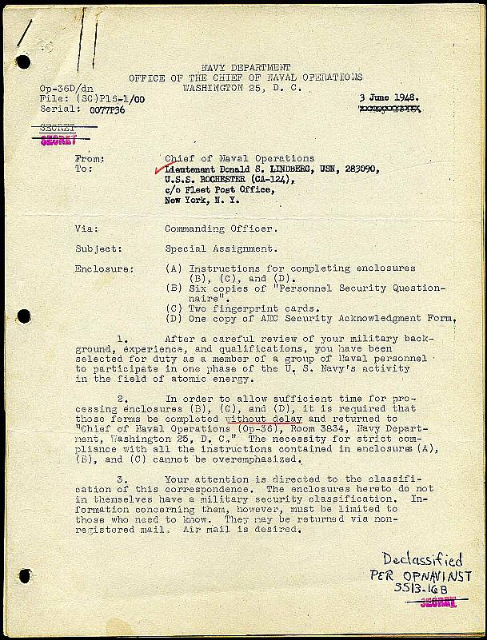

Document 2: CNO Orders Page 2 of 2
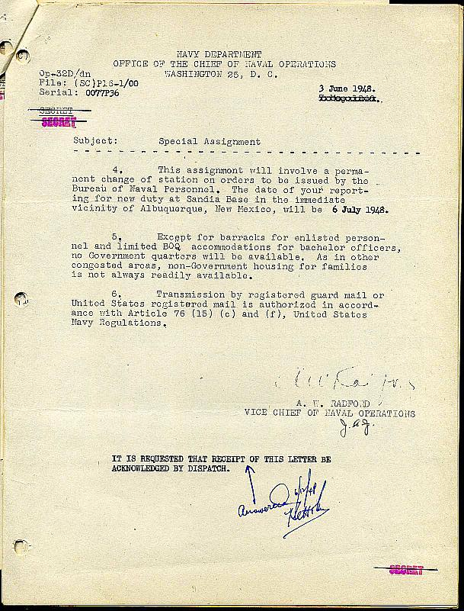
Document 3: BUPERS Message Orders

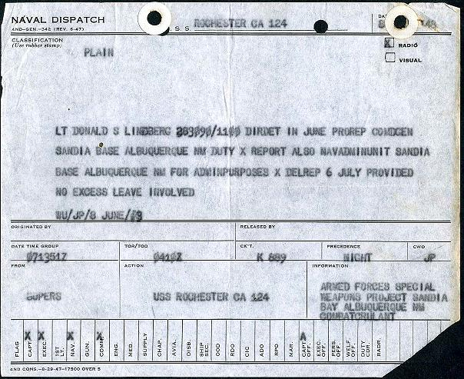

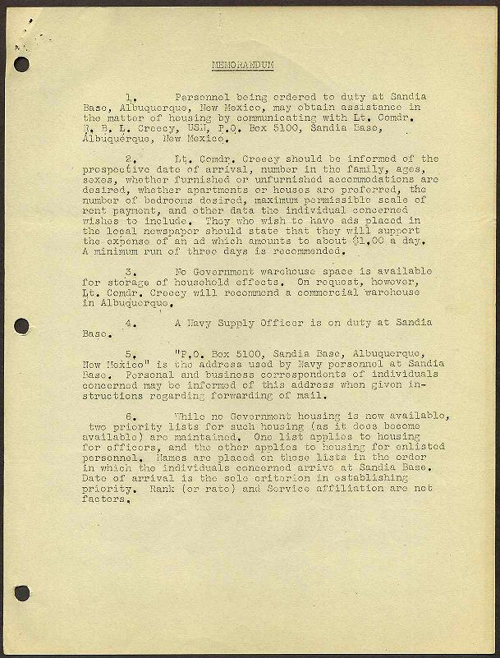
Document 4: Point of Contact Memorandum

Document 5: Instructions for Completing Security Questionnaire
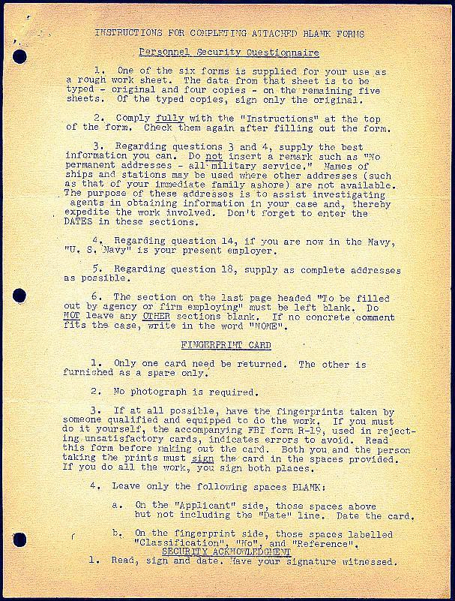

Document 6: Fingerprint Rejection from FBI
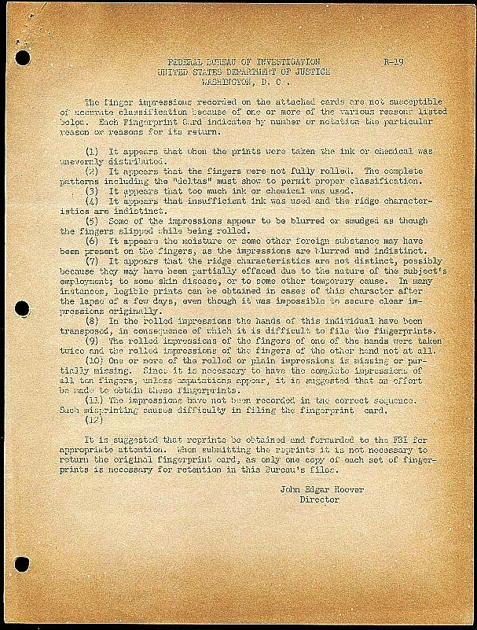

Document 7: Final Q Clearance Granted
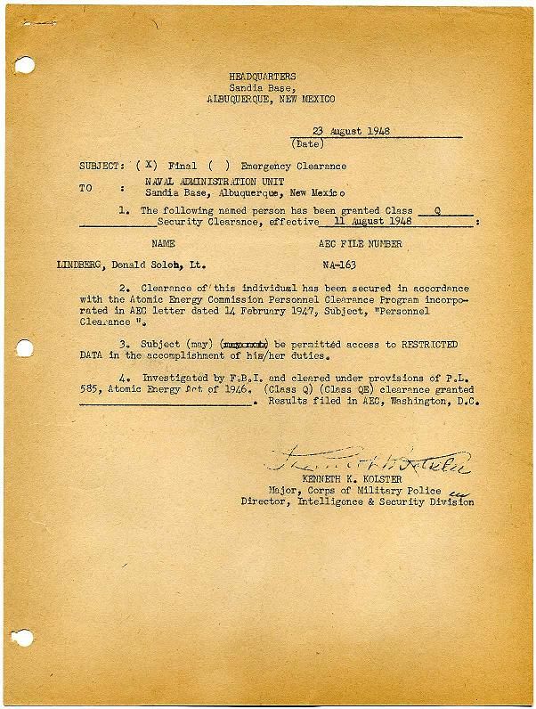

Document 8: Q Clearance Record Entry
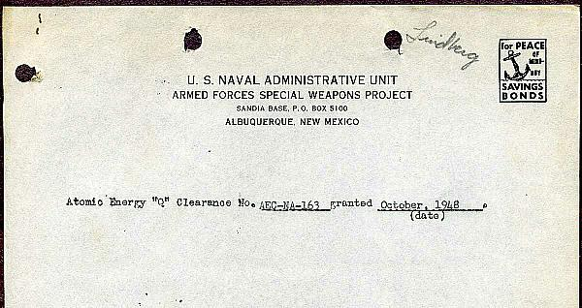

Document 9: Nuclear Supervisor Course Completion Certificate
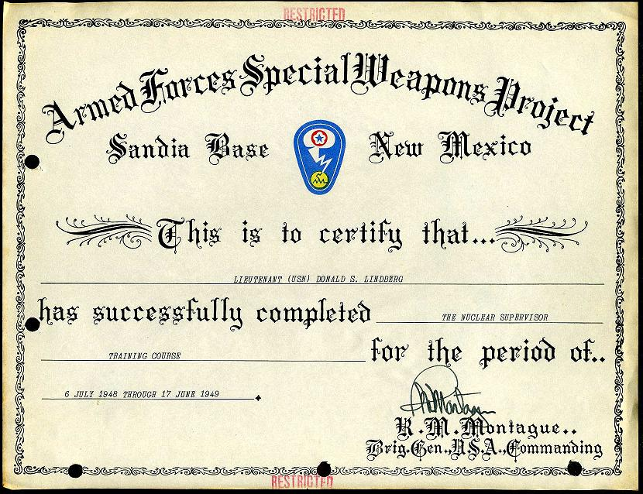

Document 10: Designation as Naval Courier
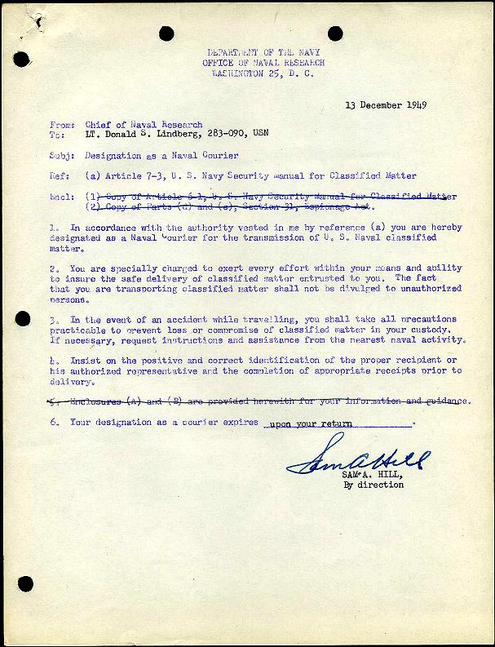

Document 11: Authorization to Visit Jaurez, Mexico
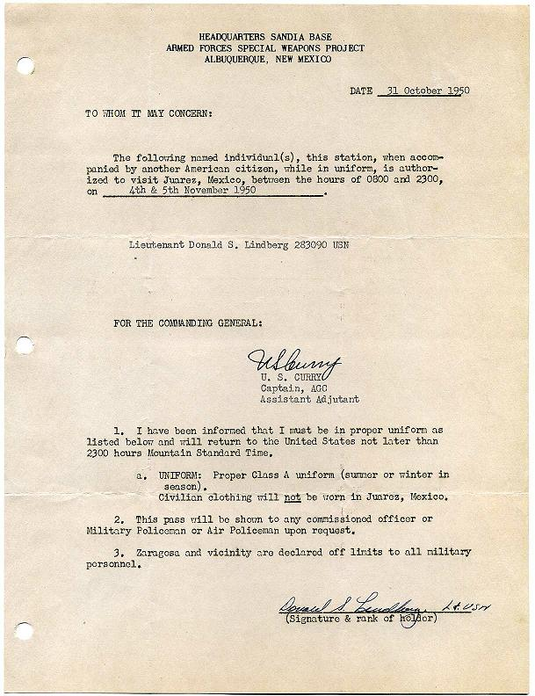

Document 12: Los Alamos Departure Letter
